Video Repository Technical Documentation
Type: SaaS Web Application
Audience: Internal Development Team
Tech Stack: PHP • MySQL • HTML
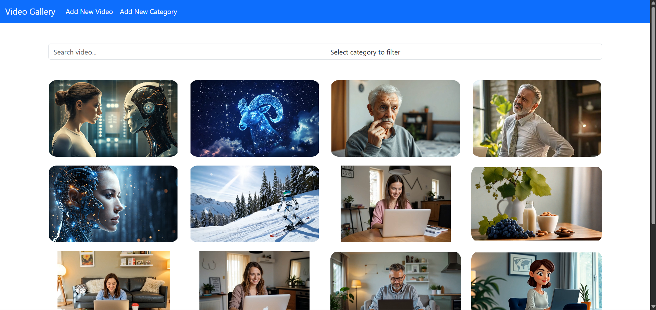

1. Overview

Purpose
Video Repository is a lightweight SaaS web application designed to serve as a centralized storage and management platform for video assets. It allows team members to upload, categorize, search, and retrieve videos efficiently through a simple browser interface.
This tool eliminates the need for multiple external storage services by consolidating all video files in one secure, internal system.

Core Features
- ✅ Video Upload — Supports direct upload through web UI.
- 🎞️ Categorization & Tagging — Each video can be tagged and grouped by project or department.
- 🔍 Search & Filter — Quickly locate videos using title, tags, or upload date.

Goals
- Provide a unified video management system for internal use.
- Improve collaboration between media and development teams.
- Maintain versioned, searchable, and secure video archives.

2. System Architecture

Overview
The system is a classic three-tier architecture composed of:
- Presentation Layer — Frontend interface built in HTML/CSS/JavaScript.
- Application Layer — Business logic handled by PHP (using MVC pattern).
- Data Layer — MySQL database for video metadata and user access control.
┌────────────────────────────┐
│ Client (UI) │
│ HTML / CSS / JS │
└────────────┬───────────────┘
│ HTTP Requests
┌───────────┴───────────────┐
│ PHP Backend │
│ Controllers & Models │
│ File Uploads / Auth │
└────────────┬──────────────┘
│ SQL Queries
┌────────────┴──────────────┐
│ MySQL DB │
│ video_data, users, tags │
└───────────────────────────┘

Main Components
Component | Description
Frontend (HTML/CSS/JS) | Provides the upload interface, video list, and filtering options.
PHP Controllers | Handle upload requests, video retrieval, user sessions, and data validation.
MySQL Database | Stores metadata such as filename, upload date, tags, uploader, and permissions.
File Storage Directory | Physical storage of video files on the server (/uploads/videos/).
Authentication Module | Verifies users through session-based login. Admins manage user roles.

Database Schema (Simplified)
Tables:
- users — user accounts and roles
- videos — metadata for each uploaded file
- categories — video categories or departments
- tags — additional keyword labels

3. Installation and Setup

Requirements
Component | Minimum Version
PHP | 8.0+
MySQL | 8.0+
Apache / Nginx | Latest stable
Storage | 50GB+ available disk space
Browser | Chrome / Edge / Firefox (latest)

Step-by-Step Setup Guide

1. Clone the Repository
git clone https://github.com/your-org/video-repository.git
cd video-repository

2. Configure Environment
Create a .env file in the root directory:
DB_HOST=localhost
DB_USER=root
DB_PASS=yourpassword
DB_NAME=video_repository
UPLOAD_DIR=/var/www/video_repository/uploads/videos

3. Create the Database
CREATE DATABASE video_repository;
USE video_repository;

SOURCE database/schema.sql;

4. Set File Permissions
Ensure the uploads folder is writable:
chmod -R 775 uploads/videos

5. Configure Apache/Nginx
Point your virtual host to the /public directory of the project:
DocumentRoot /var/www/video_repository/public

Restart your server:
sudo service apache2 restart

6. Access the Application
Open your browser and navigate to:
http://localhost/video-repository

(Change this immediately after first login.)

✅ Setup Verification Checklist
- Can upload and play a test video
- Video metadata stored correctly in MySQL
- Search/filter returns correct results
- Storage usage stats display correctly

