User Manual – Book Creator App

Overview
The Book Creator App allows users to generate book drafts with the help of AI easily. By filling in a few fields (title, topic, description, and other details), users can create a full book structure that is automatically generated and shared through Google Docs.
Go to https://unicacloud.me/make/ to start
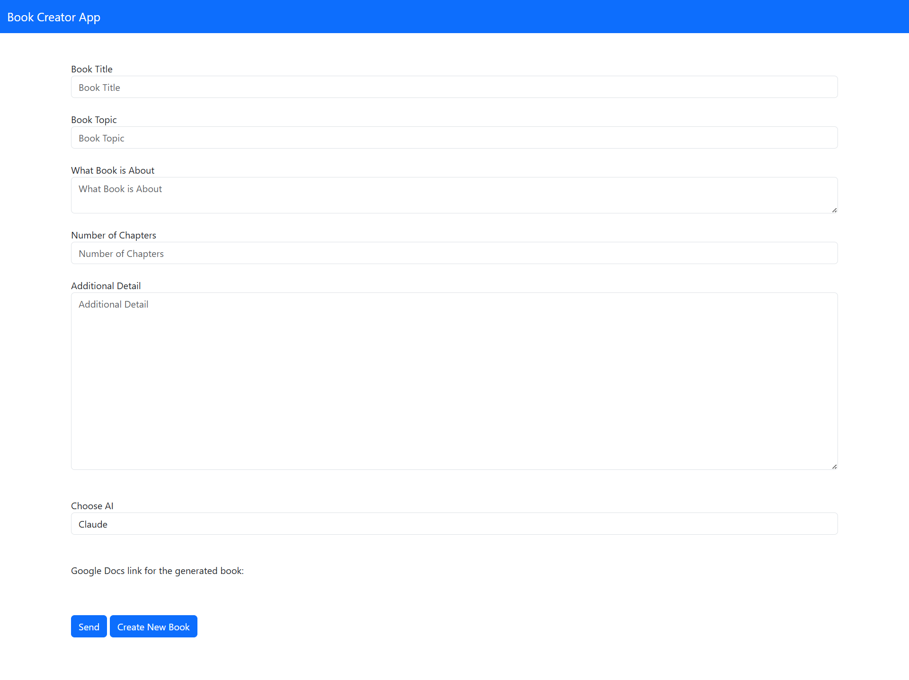

Interface Guide

1. Navigation Bar
- Title: Book Creator App – displayed at the top.
- The navigation bar has a blue background for clear visibility.

Main Form Sections

2. Book Title
- Field: Text input
- Purpose: Enter the name of your book.
- Example: The Future of AI in Education

3. Book Topic
- Field: Text input
- Purpose: Define the main subject or theme of your book.
- Example: Artificial Intelligence, Technology, Education

4. What Book is About
- Field: Text area
- Purpose: Provide a short description of what the book will cover.
- Example:
“This book explores how AI is transforming classrooms, teachers’ workflows, and student learning outcomes.”

5. Number of Chapters
- Field: Number input
- Purpose: Specify how many chapters you want in your generated book.
- Example: 10

6. Additional Detail
- Field: Large text area
- Purpose: Add any extra notes or special instructions for AI generation.
- Examples:
  - “Include interviews with experts.”
  - “Use a motivational tone.”
  - “Add real-world case studies.”

7. Choose AI
- Field: Dropdown menu
- Options: Claude (default), other AI models (if available)
- Purpose: Select which AI model will generate the book content.
- Note: The choice affects how creative or factual the output will be.

8. Google Docs Link
- Field: Text (auto-generated or paste area)
- Purpose: Displays or allows entry of a Google Docs link for the generated book.
- Example Output:
https://docs.google.com/document/d/1234examplelink

Action Buttons

9. Send
- Purpose: Submit your current inputs to the selected AI to start generating the book.
- Behavior:
  - The app sends your book title, topic, details, and preferences to the AI.
  - Wait for the process to complete; a Google Docs link may appear below once generated.

10. Create New Book
- Purpose: Clears all fields and resets the form for creating another book.
- Behavior:
  - All input fields return to blank.
  - You can start a new book project immediately.

Output
After processing, a Google Docs link will appear under the label:
“Google Docs link for the generated book:”
Click the link to view, edit, or share your generated book content.

Sequential steps to create your own book on the app.
- Fill in the details accordingly.
- Click the Send button to start the process.
- When the loading and processing of your book is finished, access the Google Docs link provided so that you can download your generated book from there.
- Click Create New Book if you are going to create a book again.

Tips for Best Results
- Be clear and detailed in the “What the Book is About” and “Additional Detail” sections.
- Choose an appropriate number of chapters to match your book’s depth.
- Experiment with different AI models (if available) to explore various styles.
- Review the generated Google Doc and refine the draft manually as needed.

Troubleshooting
Issue | Possible Cause | Solution
No link generated | Internet or AI server issue | Retry after a few minutes
Blank response | Missing required fields | Ensure all inputs are filled
Error on submission | Invalid characters or too long text | Simplify your input text

Developer’s Note:
Future versions may include support for additional AI models and automatic saving to Google Drive.

