Technical Documentation – Book Creator App & Make.com Scenario

1. Overview
The Book Creator App automates book generation using AI (Anthropic Claude, Gemini, and Perplexity AI) and integrates with Make.com to handle workflow automation between the frontend, Google Sheets, Google Docs, and webhooks.
This documentation outlines how the system works and what the next developer needs to know to update both the frontend code and the Make.com scenario.
How to access the scenario:
- Log in to make.com (make sure that your account is associated as a member to Unica’s organization on the platform).
- Select Official Book Creator App via Webhook - Claude as the default scenario. There’s another scenario, which is for Gemini and Perplexity models.

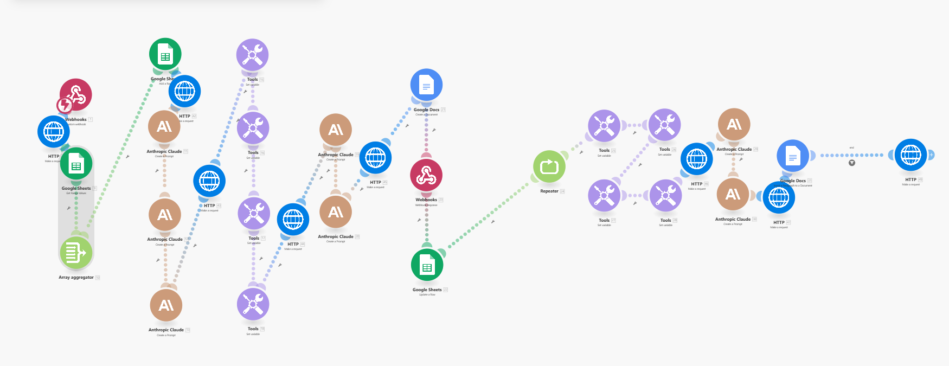
How to access the front-end source code:
- Login to unicacloud.me/cpanel (Credentials: unicacloud/RRScRhlrxrb2)
- Go to public_html, then navigate to the directory called make.
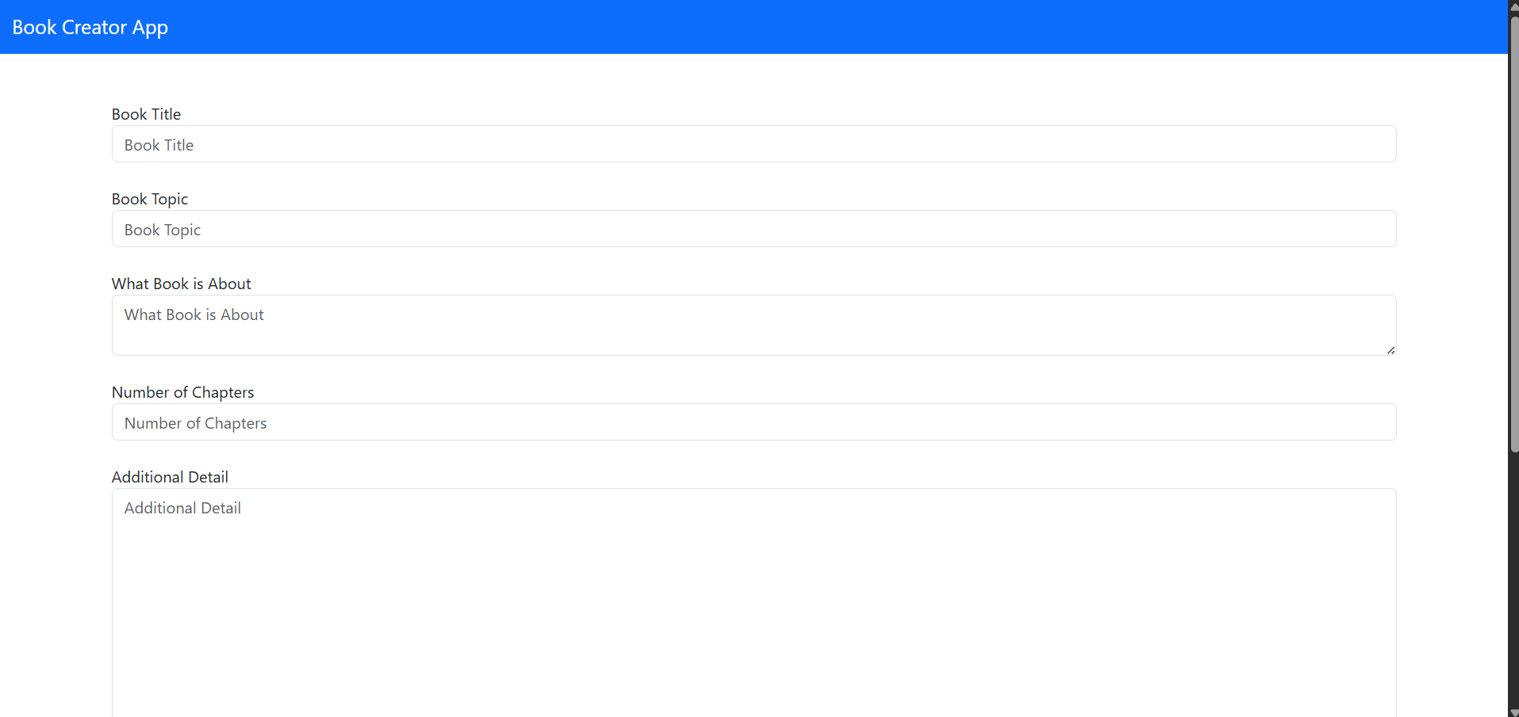
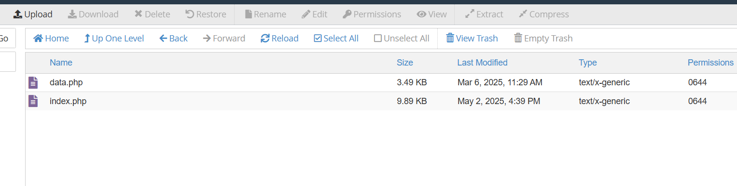

2. System Architecture

Main Components
Component | Purpose
Frontend (Book Creator App) | HTML-based form for user input and sending data to Make.com webhook
Make.com Scenario | Automation workflow connecting AI, Google Sheets, Google Docs, and HTTP requests
Anthropic Claude API | Used to generate book chapters, summaries, or full manuscripts
Google Sheets | Used for logging requests, tracking metadata, and storing generation parameters
Google Docs | Stores the final AI-generated book output
Webhook (Make.com) | Receives data from the frontend and triggers the automation chain

3. Frontend (Book Creator App)

3.1. UI Components
- Fields:
  - Book Title
  - Book Topic
  - What Book is About
  - Number of Chapters
  - Additional Detail
  - Choose AI (Default: Claude)
  - Output: Google Docs link (auto-filled after generation)
- Buttons:
  - Send: Sends form data to Make.com webhook.
  - Create New Book: Clears all inputs for a new session.

3.2. API Integration
- Webhook URL:
Defined inside the frontend script (e.g., https://hook.make.com/<unique_id>).
- HTTP Method:
POST
Payload Example:
{
"book_title": "The Future of AI",
"book_topic": "Artificial Intelligence",
"book_about": "Explores AI in education",
"number_of_chapters": 10,
"additional_detail": "Add case studies and interviews",
"chosen_ai": "Claude"
}

Expected Response:
{
"google_docs_link": "<Google Docs link of the book>"
}

3.3. Update Instructions
- Locate the send button event handler.
- Update the Make.com webhook URL if a new one is created.
- Ensure CORS settings are correctly configured for Make.com endpoints.
- Validate form data before sending to prevent empty submissions.

4. Make.com Scenario Workflow

4.1. General Flow
- Webhook Trigger – Receives payload from frontend.
- Google Sheets (Log Entry) – Records input data.
- Array Aggregator – Consolidates input fields.
- Anthropic Claude Modules – Generate:
  - Chapter outlines
  - Chapter content
  - Summaries
- HTTP Modules – Send/receive API data to and from Claude.
- Google Docs – Create or update a new document with the generated text.
- Google Sheets (Final Update) – Add Google Docs link.
- Repeater – Iterates over chapters if multiple are requested.
- Webhook Response – Sends Google Docs link back to the frontend.

4.2. Key Modules in the Screenshot
Module | Description
Webhook (Trigger) | Entry point from frontend
Google Sheets | Logs request metadata
Array Aggregator | Collects user input values for AI generation
Anthropic Claude (x5) | Multiple steps for generating book sections
Tools (Iterator / Text) | Splits, merges, and formats text between steps
Google Docs | Creates the final book output
Repeater | Loops through each chapter generation process
HTTP (blue icons) | Handles Claude API requests or Make.com internal calls
Final Webhook Response | Returns generated Google Docs URL

4.3. Data Mapping Summary
Source | Destination | Purpose
Webhook Input | Google Sheets | Logging book metadata
Sheets Data | Claude | Provides context for book generation
Claude Output | Google Docs | Creates content document
Docs URL | Webhook Response | Returned to frontend
Repeater | Claude | Iterative generation for multi-chapter books

4.4. Claude Prompt Template Example
Each Claude module typically uses a structured prompt like:
You are a professional book ghostwriter.
Title: {{Book Title}}
Topic: {{Book Topic}}
Description: {{Book About}}
Chapters: {{Number of Chapters}}
Additional Detail: {{Additional Detail}}

Generate a detailed outline or content for Chapter {{n}}.
Note: Prompts can be found and edited inside each Anthropic Claude module in Make.com.

4.4. Nodes/Modules Components and Functions
- Each Make.com module/node has its settings interface so that you can set up API connections, etc. Just click the node will setup.
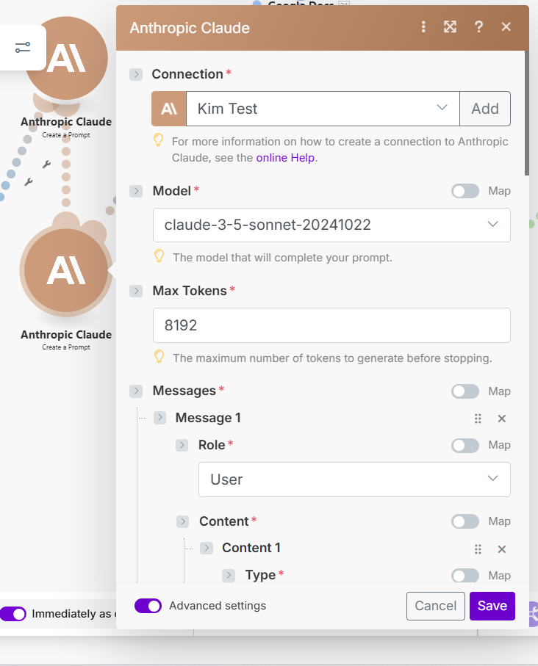

- Every node also has connectors so that the workflow sequence will be determined.
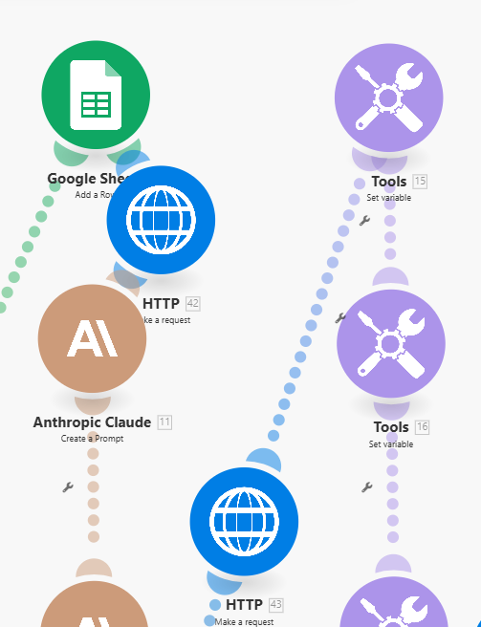

- Filters: You can set up a filter based on the logic you need to apply.
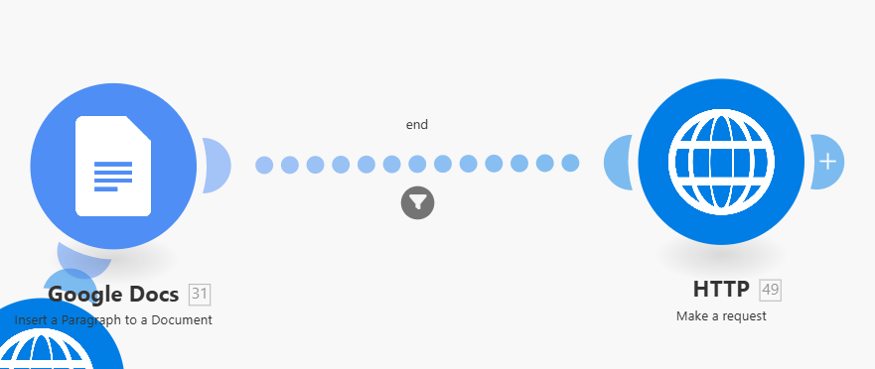
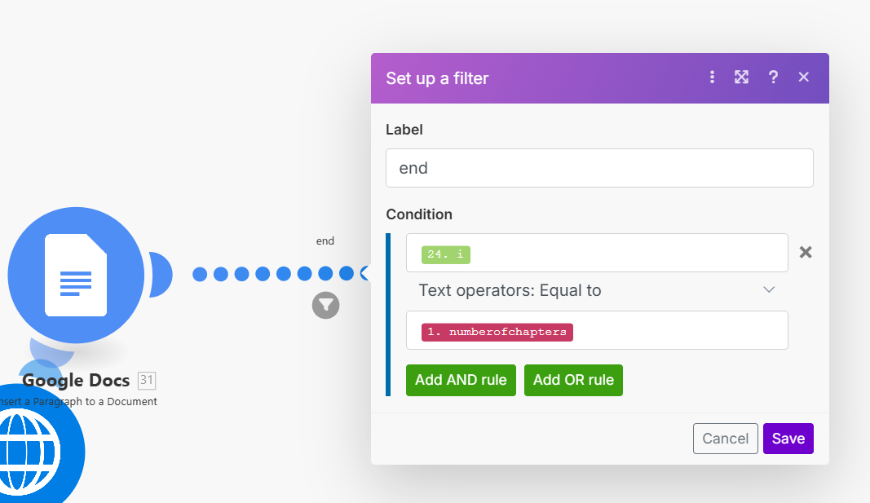

5. Maintenance Guidelines

To Update AI Logic
- Go to the Anthropic Claude modules in Make.com.
- Adjust prompts for tone, format, or structure.
- If switching to another AI, update the Choose AI logic in frontend and Make.com router.

To Update Google Sheets / Docs Connections
- Re-authenticate Google account if credentials expire.
- Verify the target Google Sheet and Doc templates exist.
- Make sure the column headers in Google Sheets match the JSON payload.

To Update the Webhook
- Create a new Webhook in Make.com (if needed).
- Replace the webhook URL in the frontend code.
- Test the connection by sending a sample request.

To Debug Scenario
- Enable “Log Execution” in Make.com.
- Test using sample data from frontend.
- Check for failed modules (red icons) and review the error logs.
- Re-run the scenario manually if partial failures occur.

6. Version Control & Deployment
Component | Recommended Tool | Notes
Frontend | GitHub / GitLab | Commit after every UI or logic change
Make.com Scenario | Duplicate before editing | Keep versioned copies for rollback
Google Sheets & Docs | Shared Drive | Maintain access permissions for service accounts

7. Future Improvements
- Add progress indicators to frontend while book generation runs.
- Include user authentication for tracking generated books.
- Support multiple AI models dynamically (Claude, GPT, Gemini, etc.).
- Store all generated data in a backend database for analytics.

Document Author: Kim Ramirez
Last Updated: October 2025
Version: 1.0

