
Atomicask Technical Documentation

1. Overview / Introduction
Atomicask is a SaaS platform that allows users to upload documents and interact with them intelligently through natural-language queries. Once a user uploads a document (such as a PDF, DOCX, or TXT file), Atomicask analyzes its content, extracts the key text data, and enables the user to ask questions directly about the document — receiving accurate, context-aware answers in real time.
The system uses advanced text-processing and semantic-search algorithms to understand context, summarize content, and deliver concise answers based on the uploaded material. ccAtomicask helps professionals, students, and organizations save time by turning static documents into interactive knowledge sources.

2. System Architecture
Atomicask follows a modular monolithic architecture built on PHP and MySQL. The application logic, presentation layer, and API endpoints are handled within a unified backend, while the frontend interfaces (web dashboard, API consumers) communicate through RESTful APIs.

🧩 Components
- Frontend (Web App) – Built with HTML, CSS (Tailwind), and JavaScript (Vue or Vanilla JS).
- Backend (Core API) – PHP 8.x running on Laravel or a custom MVC framework.
- Database Layer – MySQL 8.x for structured data storage.
- Authentication – PHP sessions.
- File Storage – Local server storage for document uploads.
- Deployment – Shared hosting with Nginx/Apache.

🏗️ Architecture Diagram
+-----------------------+
| Frontend (Web) |
+-----------+-----------+
|
| PHP Authentication
v
+-----------+-----------+
| PHP Backend |
+-----------+-----------+
|
+-----------+-----------+
| MySQL Database |
+-----------------------+

3. Tech Stack
Layer | Technology
Language | PHP 8.x
Database | MySQL 8.x
Frontend | HTML5, CSS3, JavaScript
API Format | REST (JSON)
Deployment | Nginx / Apache
Version Control | Git + GitHub
Storage | Local storage

4. Installation and Setup

🧩 Prerequisites
- PHP 8.x or later
- Composer
- MySQL 8.x
- Git
- Node.js (for frontend build if applicable)

⚙️ Installation Steps
- Clone the repository
git clone https://github.com/your-org/atomicask.git
cd atomicask
- Set up your environment
  - Make sure you have PHP 8+ and MySQL installed.
  - Create a database (e.g., atomicask_db) in MySQL.
  - Open the project’s configuration file (e.g., config.php or any DB config file) and update your credentials:
$db_host = "127.0.0.1";
$db_name = "atomicask_db";
$db_user = "root";
$db_pass = "";
- Import the database
  - Locate the SQL file (e.g., database.sql) inside the project.
  - Import it into your database using phpMyAdmin or the command line: mysql -u root -p atomicask_db < database.sql
- Run the application
Start a local PHP server: php -S localhost:8000
  - Visit the app in your browser at:
👉 http://localhost:8000

5. API Endpoints
Method | Endpoint | Description | Auth
POST | /api/auth/register | Register new user | No
POST | /api/auth/login | Authenticate and get token | No
GET | /api/users/me | Get current user profile | Yes
GET | /api/tasks | Get all tasks | Yes
POST | /api/tasks | Create new task | Yes
PUT | /api/tasks/{id} | Update task details | Yes
DELETE | /api/tasks/{id} | Delete task | Yes
GET | /api/questions | Fetch list of questions | Yes
POST | /api/questions | Create new question | Yes

Example Response
{
"status": "success",
"data": {
"id": 42,
"title": "Fix email verification bug",
"assigned_to": "kim@atomicask.com",
"status": "In Progress"
}
}

6. Database Schema

Tables

1. users
Field | Type | Description
id | INT (PK) | Primary key
fullname | VARCHAR(255) | User’s full name
email | VARCHAR(255) | Login email
password | VARCHAR(255) | Encrypted password
profilepicture | VARCHAR(255) | Path to profile image
role | ENUM('ADMIN', 'USER') | User role

2. chatbot_history
Field | Type | Description
id | INT (PK) | Primary key
chat | TEXT | Chat message content
chatfrom | ENUM('User', 'Assistant') | Message origin
chatownerid | INT (FK → users.id) | Owner of the conversation

3. chat_history
Field | Type | Description
id | INT (PK) | Primary key
document_id | INT (FK → documents.id) | Related document
chat | TEXT | Chat message content
chatfrom | ENUM('User', 'Assistant') | Sender type
chatownerid | INT (FK → users.id) | Owner of the chat

4. documents
Field | Type | Description
id | INT (PK) | Primary key
name | VARCHAR(255) | Uploaded document name
folder_id | INT (FK → folders.id) | Folder association
user_id | INT (FK → users.id) | Owner of the file
filetext | LONGTEXT | Extracted or parsed text content
fileactual | VARCHAR(255) | File path (e.g., uploads/...)

5. folders
Field | Type | Description
id | INT (PK) | Primary key
user_id | INT (FK → users.id) | Folder owner
name | VARCHAR(255) | Folder name (e.g., “Advertising”)

6. logs
Field | Type | Description
id | INT (PK) | Primary key
user_id | INT (FK → users.id) | User performing the task
date_created | DATE | Log creation date
model_used | VARCHAR(255) | Model name (e.g., gpt-4o, claude-3-opus)
token_used | INT | Token usage for the session
texts | LONGTEXT | Request or result text snippet

7. models
Field | Type | Description
id | INT (PK) | Primary key
model | VARCHAR(255) | Model identifier (e.g., claude-3-opus-20240229)

8. settings
Field | Type | Description
id | INT (PK) | Primary key
streamtemperature | FLOAT | Model temperature setting
chunksize | INT | Document chunk size
chunkoverlap | INT | Overlap between chunks
systemprompt | LONGTEXT | System-level prompt or instruction
userprompt | LONGTEXT | User-defined custom prompt
streamingmodel | VARCHAR(255) | Selected AI model (e.g., gpt-4o)
environment | VARCHAR(255) | Preset name (e.g., “Highly Detailed”)

✅ Database Name: admin_atomicask
✅ Tables: users, chatbot_history, chat_history, documents, folders, logs, models, settings
✅ Total Tables: 8
✅ Character Set: utf8mb4_general_ci

7. Deployment Guide

🌐 Manual Server Deployment
- Upload files to Plesk - Once logged in: Go to Domains -> <domain_name> -> Files
- Set permission to sensitive files like .env chmod -R 775 <file>
- Install the database to Domains -> <domain_name> -> Databases -> PHPMyAdmin

8. User Manual
- Login to https://atomicask.com/
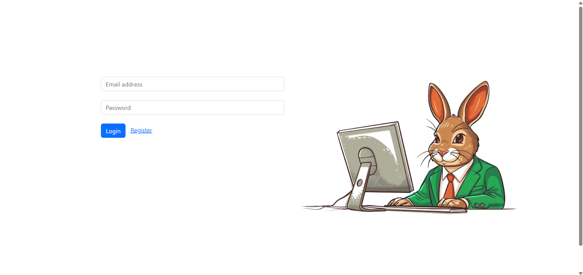

- This must be the dashboard.
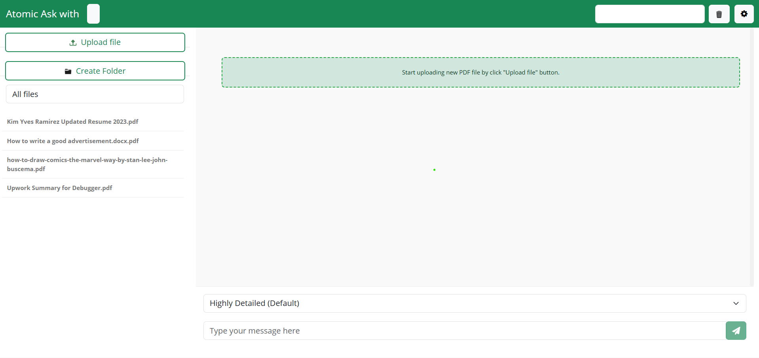

- To start a new chat, click the Upload file button.
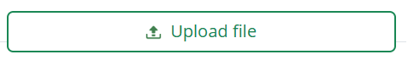

- To continue with an existing chat, click any of the chat list history on the left panel.
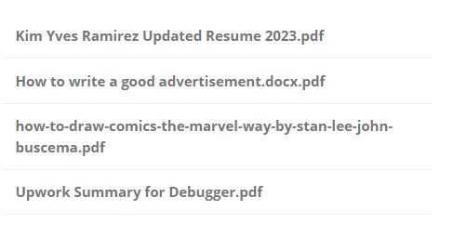
- The environment selection lets you choose the model and environment that you need for the prompt.

- After sending the prompt, the center chat panel will be the preview of all of the results of the prompts you sent.
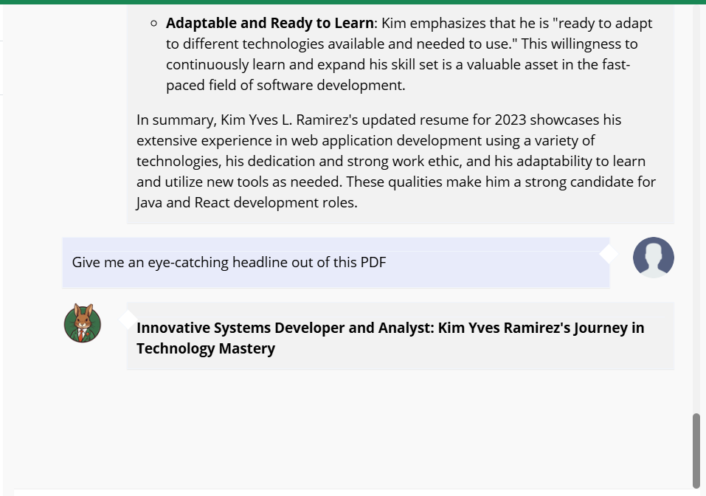

- This is the message box panel where you can write your prompt related to the document.

- This is the document preview of the selected chat.
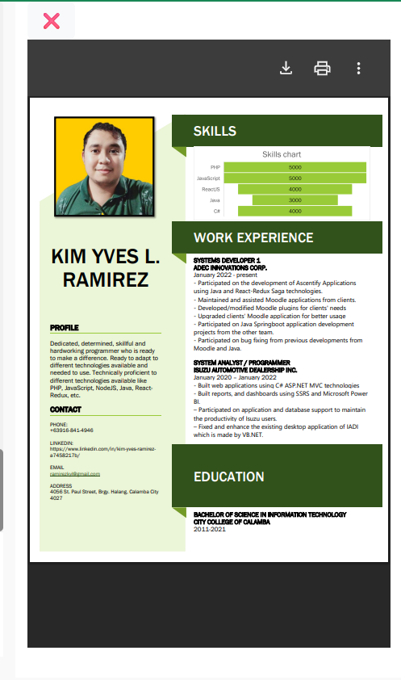

- This is the delete button where you can delete a chat history


- This is the settings button where you can adjust and create a new environment.

